Eyam C E Primary School
Newsletter
Summer Term 09.05.25



Please note weekly PE lessons - please come to school wearing PE kit and trainers (not skirts/dresses), music lessons & other weekly events.
Monday – Piano & Brass.
Tuesday – Voice & Choir, PE for Owls & Squirrels, Hedgehogs shared reading (2.50pm).
Wednesday – Woodwind, PE for Owls & Squirrels.
Thursday – Violin & Guitar, PE for Hedgehogs.
Friday – Owls CIL (clarinet)

GOOD LUCK TO OUR WONDERFUL Y6 PUPILS
We wish you the very best in your SATs next week – you should all feel proud of the way you have tackled revision and booster activities.



Week beginning 12TH May 2025
Mon  12 | Y6 SATs
Tue 13 | Y6 SATs
Wed 14 | Y6 SATs
Thu  15 | Y6 SATs  Hedgehogs Forest School 3/3  Fencing Y3/4/5/6 please wear PE kit.  3.15-4.15pm Fencing Club  3.45pm Pre-school meeting in Treetops
Fri  16 | Y6 Celebration Games at Whitworth Park  Choir performing at Buxton SDM Festival

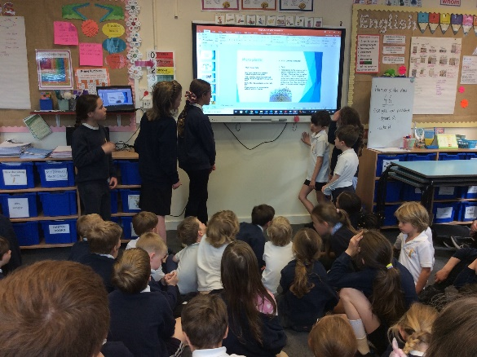

Week beginning 2nd June 2025
Mon  02 | INSET day – school closed to pupils.
Tue  03 | School re-opens  5.30pm meeting for families of new starters Sept 2025
Wed 04 | Y5/6 White Hall residential
Thu  05 | Y5/6 White Hall residential Y6 Bikeability  Y3/4 visiting Doncaster School for the Deaf
Fri  06 | Y5/6 White Hall residential

Week beginning 19th May 2025
Mon  19 | Climate Action Day – wear bright colours  Fencing Y3/4/5/6 please wear PE kit.  3.15-4.15pm Fencing Club
Tue  20 | Whole school walk community friendship walk. Please join us at 1.30pm on the yard.
Wed 21 | Science Day and Bee talk/presentation for all classes  3.15pm White Hall meeting for Y5/6 families
Thu  22 | Y5/6 Cricket at HVC
Fri  23 | Whole School Photo  Break-up for half term

Community Walk up to and along the New Road to Windy Corner – families are welcome to join us for this social event on Tuesday 20th May at 1.30pm to celebrate our topic – developing friendship along an unexpected journey.


Climate Action Day at Eyam
Please arrive in school wearing bright colours to help us celebrate the power of pollen – we are looking forward to learning all about Bees!
We have a climate Ambassador visiting and will also be exploring the solar panel exploration kit and learning about food waste and micro-plastic. These are the areas we are focussing on this year at Eyam – here is the Eco team launching the plan.

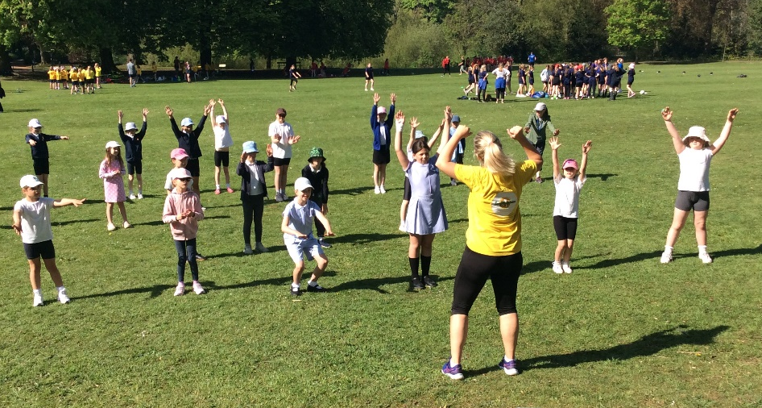
Thid Girl Can at Whitworth Park
Cricket
Bikeability
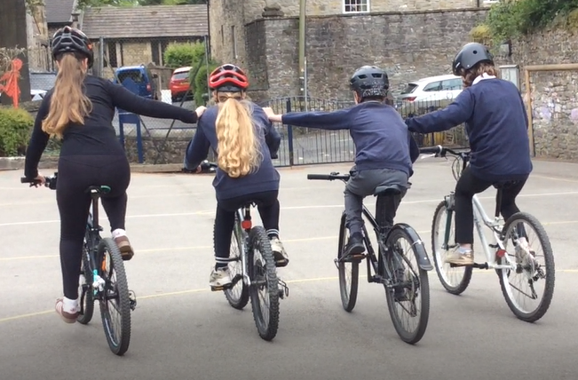
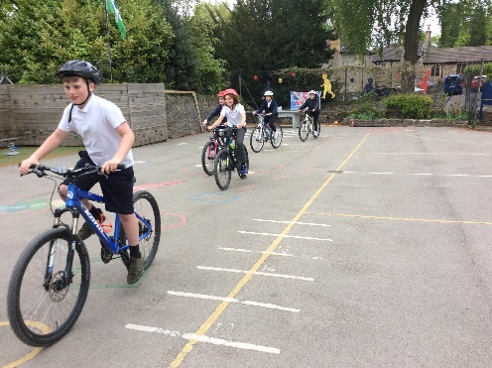
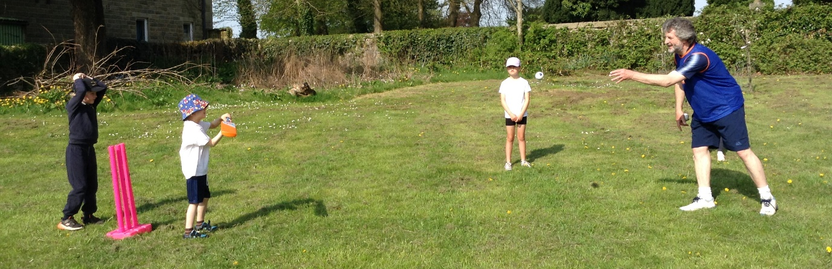
A half term of sport at Eyam

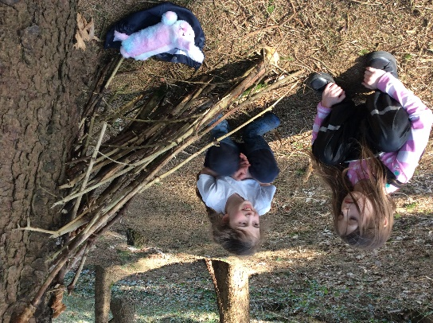
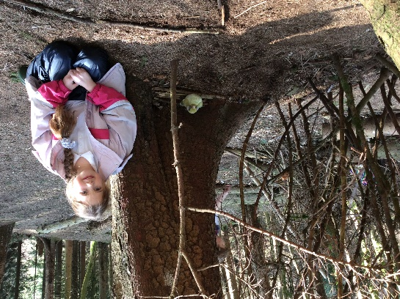
Owls had a great time at Forest School this half term – seen here practising their team building.

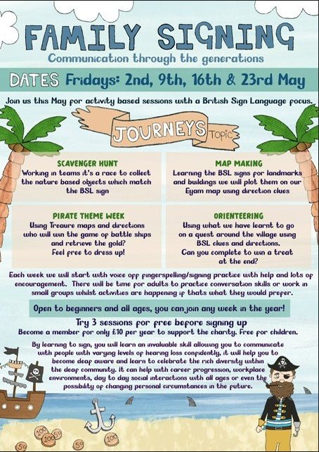

Sunny Days!

Reminder to apply sun cream to children before coming to school, to send a sun hat or cap every day (if you have a spare it can be kept in their drawer in the classroom), to bring a water bottle every day please.

WANTED - relief staff for Breakfast Club, After School Club & Mid-day Supervising.
We would like to find someone for a regular Breakfast Club slot on any or all of the following days Mon, Tue & Wed
8.10-8.45am.
Please contact the office for more information.

School Meals Theme Day
15thMay – DCC Catering invite you to “join us for the School Census Day, as we introduce the favourite melas requested by the pupils but in a school compliant way”.

If children who usually bring a packed lunch from home on a Thursday would like a school lunch on 15th May please let the office know.
R-Y2 FREE Y3-Y6 £3.25
Diary Dates
10/06/25 – Teddy Bear Club 1.30-3.00pm
12/06/25 – Squirrels Forest School 1/3
16/06/25 – Bag2School collection
17/06/25 – Teddy Bear Club 1.30-3.00pm
18/06/25 – Grass track cycling Whitworth Park
19/06/25 – Y5 STEM at Hope Valley College
19/06/25 – Golf at Gt Longstone TBC
19/06/25 – Music for the Mind (some Y5/6)
23/06/25 – Hearing Workshop Y4-6
24/06/25 – Y3/4 day visit to Lea Green
24/06/25 – Teddy Bear Club 1.30-3.00pm
25/06/25 – LMS transition day
26/06/25 – Y5 /6 Yoto Carnegie Award at LMS
26/06/25 – Y3/4 Orienteering am or pm TBC.
26/06/25 – KS1 sports at HVC 1.30-3pm
29/06/25 – PTFA Eyam Fest ‘25
01/07/25 – Teddy Bear Club 11.45am-3.00pm (stay for lunch)
02/07/25 – LMS transition day
02/07/25 – Move-up day.
03/07/25 – HVC transition day
03/07/25 – Y3/4 Tennis TBC
03/07/25 – HVC student/parent welcome evening 5.30-6.15pm
04/07/25 – Y6 Bikeability
08/07/25 – School sports day (afternoon)
10/07/25 – Big swim
15/07/25 – Teddy Bear Club 1.30-3.00pm
16/07/25 – Y6 Bikeability
17/07/25 – Y5/6 Summer Performance
18/07/25 – Squirrels Forest School 3/3
21/07/25 – Concert for all who play a musical instrument.
22/07/25 – Leavers’ Service
23/07/25 – Children break-up for summer
24/07/25 – INSET Day
04/09/25 – INSET Day
05/0//25 – INSET Day

